**“Web-based Property Unit Management System in BFAR-MIMAROPA Regional Office”**

A Research/Capstone Project

Presented to the faculty of the

College of Computer Studies

**Mindoro State University**

Calapan City Campus

Masipit, Calapan City, Oriental Mindoro

In Partial Fulfillment

Of the requirements for the Course of

**Capstone 1**

Llamoso, Aloha Chloe L.

Maderazo, Justine Rafael B.

Tabay, Renz Bryan A.

BSIT III-F3

April 2024

**Chapter I**

**INTRODUCTION**

**Project Context**

Web-based Property Unit Management System in BFAR-MIMAROPA Regional Office is designed to enhance overall organizational efficiency by providing a seamless flow of information.The Bureau of Fisheries and Aquatic Resources (BFAR) holds a crucial role in the sustainable management and development of the MIMAROPA's fisheries and aquatic resources. With a commitment to advancing operational efficiency and accountability, there is a pivotal focus on introducing an Inventory Management and Document Management System within the property section. The aim of this initiative is to transform the mechanisms governing inventory control, introducing a nuanced system for categorizing supplies.

This study aims to develop a reliable Inventory Management and Document Management System tailored to meet the unique needs of BFAR's property section. The researchers will analyze current inventory control procedures and document management practices to identify areas for improvement. Their focus is on finding technological solutions that match BFAR's goals, such as improving resource allocation, increasing transparency, and accurately tracking supplies.

At its core, this research is founded on the recognition of the pivotal role that efficient inventory and document management play in the seamless functioning of BFAR's property section. Through the adoption of modern systems, the department aims to streamline processes, mitigate manual errors, and ensure timely access to critical information. The research is anchored in the understanding that an integrated approach to inventory and document management will not only heighten operational efficiency but also significantly contribute to the overall effectiveness of BFAR's mission in sustaining fisheries and aquatic resources.

The primary focus of this research study is to design, develop, and implement a tailored Document Management and Inventory Management System that meets the unique requirements of the BFAR's property section. The thrust is to align the technological solution with the department's goals of efficient supply management, data accuracy, and resource optimization.

Cruz and Reyes (2019) conducted an examination of inventory management practices within chosen Small and Medium Enterprises (SMEs) in the Philippines. Employing a case study approach, the research delved into the strategies adopted by local businesses to ensure equilibrium in inventory levels, navigate fluctuations in demand, and tackle issues like stockouts and surplus stock. The findings from this investigation provided insights into the distinctive inventory management scenario in the Philippines, underscoring the necessity for customized solutions tailored to the needs of local enterprises (Cruz & Reyes, 2019).

In summary, the proposed web-based property unit management system marks a strategic initiative aimed at enhancing organizational efficiency and accountability in the sustainable management of the MIMAROPA's fisheries and aquatic resources. With a focus on tailored technological solutions, the research aims to streamline inventory control mechanisms, categorize supplies more effectively, and align with BFAR's objectives of efficient supply management, data accuracy, and resource optimization. This comprehensive approach recognizes the pivotal role of efficient inventory and document management in the seamless functioning of BFAR's property section, reflecting a commitment to modern systems that can mitigate manual errors, streamline processes, and ensure timely access to critical information. Top of Form

**Objectives of the Study**

The main objective of this study is to design, develop and implement an Web-based Property Unit Management System in BFAR-MIMAROPA Regional Office. Specifically, this study aims to:

1. develop a system that categorizes the supplies used and distributed by the BFAR;
2. develop a system that generates a document file regarding to the supplies that they used, distributed, and returned to them by the fisherfolks;
3. develop a system, generating reports and analytics regarding to the supplies and inventory handling and distribution;
4. optimize the return process, accurately recording and assessing damages, and facilitating collaboration between relevant departments to mitigate losses and maintain inventory integrity.
5. evaluate the performance of the developed system using ISO 25010.

**Scope and Limitations of the Study**

The research focuses on the development and implementation of a Web-based Property Unit Management System tailored to the unique needs of the Property Section within the Bureau of Fisheries and Aquatic Resources (BFAR). Encompassing a comprehensive range of property-related documents and diverse inventory items, including acquisition records, maintenance logs, and various assets, the system aims to streamline workflows by integrating document processing and inventory management. User roles and permissions will be defined to ensure controlled access, while reporting and analytics features will provide insights into document processing timelines and inventory levels. The system is designed with scalability in mind, allowing for future expansion. The research acknowledges potential challenges, including initial implementation hurdles, resource constraints impacting the system's full potential realization, and the critical dependence on data accuracy. Moreover, the system's compliance with regulatory changes requires regular updates and monitoring to ensure ongoing adherence to legal requirements. In navigating these limitations, the BFAR aims to manage expectations, allocate resources effectively, and proactively address challenges during the development and implementation of the Web-based Property Unit Management System for its Property Section.

**Significance of the Study**

The study on the " Web-based Property Unit Management System in BFAR-MIMAROPA Regional Office" would be beneficial to the following:

**BFAR Personnel.** The study can benefit BFAR personnel directly involved in property management by providing them with a more efficient and streamlined system for handling documents and managing inventory. This can lead to time savings, reduced errors, and improved overall productivity.

**Users.** Users of the system, such as property section staff, can benefit from a more user-friendly and efficient platform for managing documents and inventory. This can enhance their daily work processes and contribute to a more positive work environment.

**Researchers.** The study benefits the researchers by enhancing skills in project management and system analysis, fostering professional growth through practical problem-solving, and establishing subject matter expertise in integrated document and inventory management within the BFAR property section.

**Future Researchers.** For future researchers, the study offers valuable reference material, allowing them to build on existing findings and methodologies, thereby avoiding redundancy and promoting more efficient research processes. The study's insights can contribute to the establishment of best practices in integrated document and inventory management systems for government agencies, informing the design and implementation of similar systems in diverse organizational settings.

**Conceptual Framework**

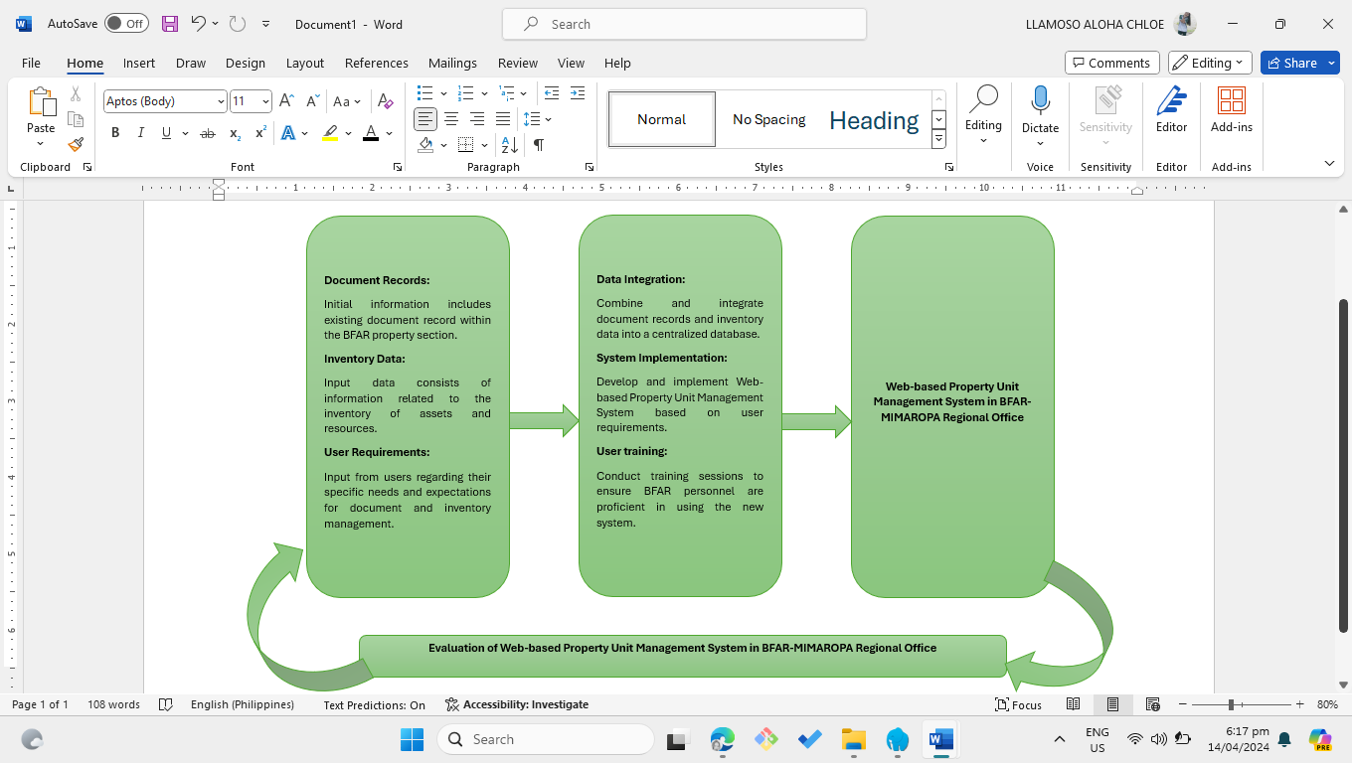

Figure 1.1

The figure 1.1 represents the flow from input to process and then to output. Inputs such as Document Records, Inventory Data, and User Requirements go through processes like Data Integration, System Implementation, and User Training to produce the output, which is the Integrated Document and Inventory Management System. The arrows indicate the flow of information through the different stages of the framework. The enhanced framework incorporates an Evaluation stage to assess the Integrated Document and Inventory Management System's performance, effectiveness, and user satisfaction. Evaluation metrics, including system reliability, data accuracy, user feedback, and adherence to initial requirements, are considered. The introduced feedback loop ensures continuous improvement and optimization of the system, with arrows representing both information flow and the cyclical nature of evaluation for ongoing enhancements.

**Definition of Terms**

**BFAR Personnel.** It refers to the persons who are working in the BFAR that involved in the property section.

**Document management.** the process of handling documents throughout their lifecycle within the department.

**Inventory management.** It is the process of handling and keeping track of all the supplies in the BFAR.

**Property Section.** It pertains to the department that keep the supplies in the BFAR.

**Chapter II**

**REVIEW OF RELATED LITERATURE**

This chapter is a discussion of literature and the results of other related research to which the present study is related or similar. This gave the authors enough background in understanding the study.

Inventory is a pivotal aspect of supply chain management and logistics within the material management system, serving as a core function in central management. Whether aligned with organizational objectives for customer satisfaction or humanitarian needs, maintaining control over inventory is vital for operational success and overall organizational performance. (Munyaka Baraka, Jean-Claude & Yadavalli, Sarma. (2022)) (Antonova A.S., 2019). An Inventory Management System is a web-based application designed to oversee and control an organization's stock. Leveraging technology, this system focuses on efficiently processing and managing the inventory of an organization (Mariom Akter, M. (2019)). A system that monitors inventory levels, orders, and sales to conduct predictive analysis and acquire forecasted demand can effectively mitigate overstock and out-of-stock scenarios. An effective inventory management system should strike a balance, maintaining sufficient stock in the warehouse to sustain business operations without tying up excessive capital. This is a challenging task that requires anticipating all business needs, addressing crisis calls, and finding proactive solutions by the individuals responsible for inventory management (Javaregowda, Madhuri & B, praveen & Kumar, Pradyumna & J, Prateek & G, Pragathi. (2020)). A surge in stock levels leads to excessive warehouse stocking and a rise in the amount of working capital required (Weißhuhn S., Hoberg K., 2021).

The inventory management problem is choosing a compromise solution that considers various schemes for the functioning of repair parts supply programs and the overall production program. Simultaneously, issues related to inventory management, which are organizational and managerial in nature, exhibit stochastic characteristics and pose challenges in formalization (Israilova S., Mukhanova A., Yesikova T., 2021) (Rachih H., Mhada F.Z., Chiheb R., 2022).

(C. Vanessa Muñoz Macas, J. Andrés Espinoza Aguirre, R. Arcentales-Carrión and M. Peña 2021) explores the realm of inventory management in Small and Medium-sized Enterprises (SMEs) within the retail sector, covering the years 2015 to 2019. The study identifies prevailing trends, models, and indicators in SMEs, emphasizing the prevalent use of simpler solutions like Enterprise Resource Planning (ERP), Excel, or manual methods.

The study of (Yuvaraj, K., Oorappan, G. M., Megavarthini, K. K., Pravin, M. C., Adharsh, R., & Ashwath Kumaran, M. (2020)) (Stolyarov, V.; Pásztorová, J.; Zos-Kior, M.; Hnatenko, I.; Petchenko, M. 2022) addresses the challenges in the classical way of inventory logging, such as human mathematical ability, paper maintenance, untidy editing processes, and the potential for missing invoice and outward data. Their solution is to develop an inventory management application using Tkinter and SQLite. The proposed solution involves creating a customized inventory management system that transitions from traditional methods to a fully connected digital system. The application is presented as a one-time investment with no need for further investment in case of problems or errors caused by human mishandling. The use of structured language (SQL) is emphasized for quick data retrieval without time delays, and the structured nature of SQL is noted for avoiding human errors. Just like our study, BFAR faces challenges regarding the way of their inventory. We can lessen the human error and the risk of missing crucial data in the invoicing and outward processes.

(M. Shanmugaraja, P. Manojkumar, K. P. N. Govarthan, and R. Nandhakumar) explores the significance of inventory management in product manufacturing companies, emphasizing the integration of various elements such as information, transportation, acquisition, inspection, and control of supplies. The researcher aims to understand the role of different inventory management approaches, including information technology, FSN, and ABC methods, on the performance of manufacturing companies as well as our study which aims to understand the role of different inventory management approaches on company performance. This connection reinforces the idea that well-managed inventory is crucial for achieving operational excellence and overall success in the manufacturing sector.

The implementation of an extended inventory management method for multi-product mass production is the best way to solve the problem faced by the small and medium enterprise factories. These factories often face challenges in managing a wide variety and large number of products, leading to inefficiencies and economic losses due to issues like excess inventory and stock shortages. The paper proposes a solution by real-time data collection technology, specifically employing character extraction on labels with barcodes and QR codes. This study is related to our study because with regards in inventory levels, real-time data collection allows for immediate tracking of the quantity and status of various assets and resources, such as equipment, tools, and supplies. By employing real-time data collection, the BFAR (Bureau of Fisheries and Aquatic Resources) property section can track various aspects related to the management of its assets and resources (Jang, S.-H., & Jeong, J. (2019)).

The presentation of an integrated inventory model for a supply chain system involving a vendor and a buyer is the main topic that discussed in the paper. The system addresses stochastic demand and imperfect production conditions. The vendor employs a hybrid production system that combines regular and green production methods, with the latter being environmentally cleaner but more costly. The production rate is adjustable and affects both production cost and emissions resulting from production and reworking processes. The imperfect production system generates a certain percentage of defective items, and the vendor is willing to invest in reducing the defect rate. The objective of the model is to minimize supply chain costs by optimizing shipment quantity, production allocation, number of shipments, safety factor, defective rate, and production rate. The paper proposes an iterative procedure to achieve the optimal solution, and a numerical example is provided to illustrate the model's application. The results highlight the effectiveness of investing in defect reduction, controlling production rates, and determining production allocation in reducing defective items and managing the trade-off between production emissions and cost (Jauhari, W. A., Pujawan, I. N., & Suef, M. (2023)).

The author’s main idea to the study is Purchasing & Supply Management (PSM) competencies, which are considered foundational at the individual level for the overall performance of organizational PSM. The study investigates the current and future competencies required by PSM professionals considering recent developments in the workplace and the external environment. The findings reveal that the most crucial current competencies for PSM professionals include negotiation, communication, relationship management, strategy, analytics, and professional knowledge (Bals, L., Schulze, H., Kelly, S., & Stek, K. (2019).

An Electronic Document Management System (EDMS) is a platform that employs electronic media for storing files, having undergone digitization, and featuring a search function to facilitate the retrieval process (Andriansyah, R., & Elmi, F. (n.d.)). Currently, a document management system (DMS) stands out as one of the most influential organizational tools that enterprises rely on (Ferro, N. (2020)).

The primary focus of the research is to establish a model of best practices, serving as an exemplary case for organizations intending to adopt Electronic Document Management System (EDMS) in the future. The study aims to assess the effectiveness of EDMS concerning managerial control, efficiency, job satisfaction, and safety. Employing a descriptive and cross-sectional approach, the study involves employees from the central and provincial offices of the Ministry of Science, Industry, and Technology in Turkey (Abacı, K., & Medeni, I. T. (n.d.)).

The study claims scientific novelty in introducing a technology for the electronic document circulation system in Iraqi state institutions based on a universal model compliant with international standards. The practical significance lies in the application of the proposed model to enhance the qualitative and quantitative characteristics of the public institution's management system. It involves analyzing existing electronic document management systems, developing a model specific to the state institution of Iraq, and configuring workflow using the electronic document management system Case (Jalal, M. J. (2022)).

The study revolves around the significance of implementing an Electronic Document Management System (e-DMS) as a crucial component of digital transformation, with a particular focus on public institutions like universities. An e-DMS is described as an information system designed to handle various aspects of document management, including creation, distribution, filing, storage, searchability, destruction, and archiving, all of which are vital elements in the broader process of digital transformation. It underscores the challenges associated with traditional correspondence processes in public institutions, specifically highlighting universities, where manual and time-consuming activities can lead to increased workloads and bureaucracy. To address these challenges, the selection and implementation of suitable e-DMS software are deemed critical. The e-DMS is expected to systematically support institutions in managing the documents generated throughout their work processes (Özgür Polat, L. (2022)).

The study centers around the creation of a secure digital document management platform, utilizing a combination of Blockchain and IPFS technologies. It addresses the challenges of digitization in government and private organizations, including infrastructural constraints, document redundancy, and the risks of cyber fraud. The authors propose a solution by advocating for a secure digital document management system built on Blockchain Technology. They describe the development of a web application that processes digital documents, generates certificates from predefined templates, and securely stores document identifiers on a distributed Blockchain network (Polygon) and the actual documents on IPFS. The paper underscores the advantages of this approach, highlighting increased security, a reduced risk of digital forgery, and the capability to verify document authenticity. Additionally, the system allows users to securely share document access for a specific duration, providing enhanced control over document sharing (Sarang, S., Rana, D., Patel, S., Savaliya, D., Rao, U. P., & Chaurasia, A. (2022)).

The study describes the design and development of an online management system for the extension and community relations unit of a university. The purpose of this system is to facilitate the submission, approval, report generation, and document storage processes related to extension programs and projects. The motivation behind this initiative is the shift of operations and processes online due to the COVID-19 pandemic. The system is intended to ensure the timely delivery of quality extension programs to underserved and underprivileged communities while reducing unnecessary exposure to the virus. Key design elements of the online management system include ease of use, accessibility, and the ability to produce downloadable and printable documents for submission to external agencies (Paul, & Estrera, Paul Joseph & Teresa, Maria & Fajardo, Maria Teresa & Sermona, Nivea Louwah & Sermona, D. (2022)).

The introduction of electronic document management systems in the context of solving management problems and integrating them into global, regional, corporate, and local information and educational systems. The text highlights the increasing prevalence of electronic document management in both private institutions and state universities, emphasizing its advantages in effective management of financial, material, human, and other resources. The goal is to enable dynamic development in education and reach a new level of efficiency. The overall focus is on improving the efficiency of document management as a key aspect of enhancing educational activities (AZ Abdulhamidovna - Confrencea, 2023).

The study focuses on the development of a Document Management System (DMS) for case files at MMAKS Advocates. Objectives include identifying record types, assessing the current manual DMS, understanding challenges, and establishing requirements for a new DMS. Employing a case study qualitative research design with purposive sampling, the study uses interviews, observations, and document reviews. Various record types managed at MMAKS Advocates are identified. Challenges with the current manual DMS include inadequate funding and a lack of skilled staff and facilities. The study recommends adopting a case file DMS, increasing funding, digitization, staff training, and hiring more records officers to enhance document management. Additional recommendations include implementing training, establishing a records management policy, limiting access to records, utilizing a retention schedule, conducting weeding and appraisal, and employing a file plan for overall improvement in Document Management Systems at MMAKS Advocates (Mukamba, J., Twinomugisha, B., Barigye, S., & Nimusiima, D. (2022)) (Nakibondwe, R., Okuga, S., Awor, H., Kyampeire, B., Kutusiime, A., & Nabuyobo, P. (2021)).

The research is centered on identifying and prioritizing factors that impact the implementation of an electronic document management system (DMS) and examining its effects on client satisfaction. Using a descriptive-correlation research design of an applied and exploratory nature, the study employs two questionnaires—one for directors at the Hormozgan province registry and another for clients of the civil registry. The primary goal is to identify key factors influencing the electronic DMS and to comprehend their implications for client satisfaction. To sum up, the study aims to gain insights into the critical elements for the successful rollout of an electronic document management system and their repercussions on client satisfaction within the administrative framework, particularly in the Hormozgan province (Davali, M. M., & Poorahmadzadeh, S. (2023)) (Thasakdinan, N., & Rungsrisawat, S. (2019)).

The study underscores the significance of legal frameworks in personnel records management for ensuring accountability, focusing on Garissa County Government (GCG). The study investigates these frameworks, highlighting their role in supporting accountability, especially concerning Freedom of Information (FOI) or Open Data. Guided by records life cycle and records continuum concepts, the research identifies challenges at GCG, including the lack of a personnel records management policy, integrity issues, document loss, and a deficient communication system. The overall conclusion emphasizes the critical importance of establishing legal frameworks for personnel records management to enhance accountability. The study recommends that GCG management should take specific measures to enhance the legal infrastructure and develop a comprehensive policy for personnel records management (Makwae, E. N. (2021)).

The study, conducted at Sokoine University of Agriculture (SUA) in 2022, focused on assessing the efficacy of the Electronic Document Management System (EDMS) in enhancing accessibility and usage of records. With 100 SUA staff as respondents, the research found that the use of SUA-EDMS was widespread, particularly for documents related to leave of absence, annual leave, and maternity leave. While acknowledging the system's positive impact in reducing paperwork, respondents highlighted areas for improvement, such as broader document accessibility and system stability. Recommendations included enhancing internet speed, ensuring a stable power supply, exploring alternative power sources, allowing users to recover passwords independently, and providing regular training on EDMS usage and change management. Overall, the study emphasizes both the benefits of EDMS and the need for continuous enhancements to optimize its functionality (Ferro, N. (2020)).

This research focuses on identifying and analyzing the factors influencing the acceptance of an electronic document management system (EDMS) within Iran Gas Company. The study aims to enhance understanding of these factors for effective synchronization and readiness for future developments. Using a methodology that combines literature review and confirmatory factor analysis, the research targets employees with EDMS experience. It integrates the technology acceptance and use model with contextual factors and learning. The study underscores the importance of the user interface, support from senior managers, and employee skill development in fostering the acceptance and utilization of the electronic document management system within Iran Gas Company (Sadabadi, A. A., Sheykh Shoaei, H., & Rahimi Rad, Z. (2022)).

The Bureau of Fisheries and Aquatic Resources (BFAR) is tasked with overseeing the enhancement, advancement, administration, and preservation of the nation's fisheries and aquatic resources.

The study highlights the economic importance of the Philippine fisheries sector, emphasizing its role in providing income through foreign exchange and livelihood sources for a substantial number of Filipino fisherfolks. The significance of the fisheries sector in the Philippines. The passage provides key statistics and information about the country's contribution to world fisheries, including total production from various sectors (aquaculture, municipal, and commercial fisheries), its ranking among top fish-producing countries, and its standing as a major seaweed producer globally (Tahi̇luddi̇n, A., & Terzi̇, E. (2021)).

The literature review offers a thorough understanding of inventory management systems and electronic document management in diverse organizational settings. It emphasizes the importance of strategic inventory control, addresses challenges, and highlights the shift towards innovative digital solutions. In electronic document management, the review underscores the significance of EDMS for efficiency and safety, showcasing adaptability to challenges like the COVID-19 pandemic and introducing novel technologies like block chain. Insights into legal and administrative document management practices stress effective implementation strategies and adherence to legal frameworks.

The review concludes by emphasizing the economic importance of the Philippine fisheries sector and BFAR’s role, providing context for understanding the challenges faced by the organization. Overall, it sets the groundwork for the present study, offering valuable insights and solutions to inventory and document management complexities, particularly pertinent to BFAR’s mission.

**Chapter III**

**METHODOLOGY**

In this chapter, we'll discuss the ways we conducted our study to achieve its goals. We used various methods, strategies, analyses, and tools to collect and evaluate data. These steps helped us researchers effectively handle and oversee the research process.

Development Method

In this study, we used a quantitative research method, which involves collecting data in a structured way from a large group of people that represents the whole population. This approach gives us logical, statistical, and unbiased findings. We gathered information from current and potential customers by using methods like online surveys or questionnaires. The results are presented in numerical form, and by carefully analyzing these numbers, we can predict future trends for a product or service and make improvements based on the findings.

**Figure 2. SDLC Agile Model**

**Requirements.** The researchers carried out an interview, securing the client's consent, to acquire additional details about the inventory and document procedures. The gathered information was instrumental in enhancing the system functions and incorporating features that align with the client's expectations.

**Design.** The researchers focused on creating a visual design that's easy to use. They made sure the interface for managing inventory is simple for both administrators and staff. The system's structure was planned to handle updates in real-time and connect with other tools for managing inventory. Additionally, the researchers studied how the database is organized, which will be useful in building the system.

**Development.** During this stage, the researchers begin creating the different parts of the system step by step. They write the code using Visual Studio, and for added security and simpler coding, they use Laravel. Vue.js is employed for the interface, and MySQL serves as the database platform.

**Testing.** This stage focused on the system and was checked to make sure it does what it's supposed to do. The researcher showed how it works to everyone using it to make sure it meets the user's needs and fixes any mistakes. The researchers tested it in different ways, like negative testing, unit testing, and acceptance testing.

**Deployment.** During this stage, the new system was introduced gradually. Staff members were taught how to use the updated inventory and document system step by step. The rollout began with a small number of products to make the transition easier. Training sessions were held to help employees understand the new features and procedures.

**Review.** In this phase, the system had been implemented in the BFAR’s Property Section, and the client had evaluated its performance. Feedback from client was incorporated into subsequent iterations, ensuring that the system continued to meet the evolving needs of the department. The researchers conducted a survey questionnaire through google forms and printed questionnaires that based on the ISO 25010 and distributed it to employees, manager, and the IT experts. After the evaluation, the researcher tallied all the results from the questionnaires and got each overall mean and verbal interpretation.

**Gantt Chart**

The table below represents the schedule and plan of the development of the system. The requirement phase was scheduled for the month of November 2023 with the task will to be completed. The Module 1 admin account development of the system was completed in the 4th week of March 2024.

|  |  |  |  |  |  |  |  |  |  |  |  |  |  |  |  |  |  |  |  |  |  |  |  |  |
| --- | --- | --- | --- | --- | --- | --- | --- | --- | --- | --- | --- | --- | --- | --- | --- | --- | --- | --- | --- | --- | --- | --- | --- | --- |
| **TASK NAME** | | | **TASK DATE** | | | | | | | | | | | | | | | | | | | | | |
| **2023-2024** | | | | | | | | | | | | | | | | | | | | | |
| **NOVEMBER** | | | | **DECEMBER** | | | | | | **FEBRUARY** | | | | | **MARCH** | | | | | | |
| 1st | 2nd | 3rd | 4th | 1st | 2nd | 3rd | | 4th | | 1st | 2nd | 3rd | 4th | | 1ST | | 2ND | | 3RD | | 4TH |
| **1. Requirement Phase** | | |  |  |  |  |  |  |  | |  | |  |  |  |  | |  | |  | |  | |  |
| 1.1.Group Planning/Meeting | | |  |  |  |  |  |  |  | |  | |  |  |  |  | |  | |  | |  | |  |
| 1.2. Meeting with Client | | |  |  |  |  |  |  |  | |  | |  |  |  |  | |  | |  | |  | |  |
| 1.3. Research | | |  |  |  |  |  |  |  | |  | |  |  |  |  | |  | |  | |  | |  |
| **2. Design** | | |  |  |  |  |  |  |  | |  | |  |  |  |  | |  | |  | |  | |  |
| 2.1. Logical | | |  |  |  |  |  |  |  | |  | |  |  |  |  | |  | |  | |  | |  |
| 2.2. Physical | | |  |  |  |  |  |  |  | |  | |  |  |  |  | |  | |  | |  | |  |
| 2.3. Architecture | | |  |  |  |  |  |  |  | |  | |  |  |  |  | |  | |  | |  | |  |
| **3. Development** | | |  |  |  |  |  |  |  | |  | |  |  |  |  | |  | |  | |  | |  |
| 3.1. Module 1 (Admin Account) | | |  |  |  |  |  |  |  | |  | |  |  |  |  | |  | |  | |  | |  |
| 3.2. Module 2 (Costumer Account) | | |  |  |  |  |  |  |  | |  | |  |  |  |  | |  | |  | |  | |  |
| **4. Testing** | | |  |  |  |  |  |  |  | |  | |  |  |  |  | |  | |  | |  | |  |
| 4.1. Module 1 (Admin Account) | | |  |  |  |  |  |  |  | |  | |  |  |  |  | |  | |  | |  | |  |
| 4. 2. Module 2 (Costumer Account) | | |  |  |  |  |  |  |  | |  | |  |  |  |  | |  | |  | |  | |  |
| **5. Deployment** | | |  |  |  |  |  |  |  | |  | |  |  |  |  | |  | |  | |  | |  |
| 5.1. User Training | | |  |  |  |  |  |  |  | |  | |  |  |  |  | |  | |  | |  | |  |
| 5.2. Monitoring | | |  |  |  |  |  |  |  | |  | |  |  |  |  | |  | |  | |  | |  |
| 5.3. Survey Questionnaire | | |  |  |  |  |  |  |  | |  | |  |  |  |  | |  | |  | |  | |  |
| **6. Review** | | |  |  |  |  |  |  |  | |  | |  |  |  |  | |  | |  | |  | |  |
| 6.1. Review the system | | |  |  |  |  |  |  |  | |  | |  |  |  |  | |  | |  | |  | |  |
| LEGEND: |  | Done |  | | | |  | | |  |  |  | | | | |  | |  | |  | |

**Requirements Specifications**

To use the system properly, users need to understand how it works and meet certain criteria. This involves knowing how the system functions, using the interface, connecting with other software and hardware, and ensuring security. Users should also get to know the system's processes and procedures.

**Functional Requirements**

Functional requirements explain how a system operates and the correct way to use it to prevent unwanted issues. In this section, we'll talk about how the system looks and how it handles data to generate a working result. Discussing the functional details of the suggested system is crucial for the understanding of future researchers.

Table 2. Functional Requirements

|  |  |
| --- | --- |
| Features | Description |
| Supply Categorization  Document Generation  Reporting and Analytics System  Optimized Return Process  ISO 25010 Compliance  User Authentication and Access Control  Data Security and Privacy | The system should allow users to categorize supplies used and distributed by the BFAR. It must support the creation and management of supply categories and subcategories. Users should be able to assign supplies to specific categories/subcategories.  Generate document files that detail supplies used, distributed, and returned by fisherfolks. Include information such as supply name, quantity, date, and recipient details. It should support various document formats (e.g., PDF, Excel) for flexibility in sharing and storage.  The system must have reporting functionality to generate detailed reports on supplies, inventory, and distribution. It should include analytics features to analyze trends, usage patterns, and inventory status. Users should be able to customize reports based on specific criteria and timeframes.  The system should facilitate an optimized return process, recording returns accurately. It must include a mechanism for assessing damages and categorizing them based on severity. The system should update inventory records in real-time based on returned supplies.  The system should adhere to ISO 25010 standards for software quality characteristics. It must demonstrate performance efficiency, reliability, usability, and maintainability. Compliance with ISO 25010 should be verified through regular assessments and audits.  Implement secure user authentication to ensure only authorized personnel can access the system. Role-based access control should be in place, limiting user access to specific functionalities based on their roles.  The system should employ encryption methods to secure sensitive data during transmission and storage. Compliance with data protection regulations and privacy standards must be ensured. |

**Hardware Interface**

The project uses hardware that meets the necessary specifications for developing the system. The hardware interface in this method outlines the characteristics of how the software product interacts with the physical components of the system. The team utilized an Intel Core i5 processor, 8GB of RAM, and a 512GB storage capacity, which is enough for storing the operating system, database, files, and other essential items.

**Software Interface**

The software interface is crucial as it shows how the system differs from other software parts, like the database, operating system, tools, libraries, and integrated commercial components (mentioning their names and versions). In our web application, we employed various applications such as Sublime Text for PHP, MySQL server for managing the database, and PHP scripting language, CSS, Bootstrap, Ajax, and HTML for development.

**Security Requirements**

Before figuring out if the program is safe, the researchers first investigated what a security requirement means. They made sure that only the right people can get into the system. The admin and users can use a username and password to get access.

**Technical Background**

The technical background provides important details about the technical parts of the project, making it simpler to explain what developers need in easy-to-understand terms. The following sections cover the specifications for both hardware and software.

**Hardware Specifications**

Hardware specifications are details about the technical aspects of hardware items, including their components and abilities. Table 3 below shows the various hardware components needed to ensure the project is fully equipped.

|  |  |  |  |  |
| --- | --- | --- | --- | --- |
| **Hardware** | **Functions** | **Specifications** | | **Unit** |
| **Minimum** | **Recommended** |
| Processor | The component that oversees all the arithmetic, logical, and input/output tasks of a computer system by executing its instructions is referred to as the computer’s CPU | 3.4 GHz | 3.8/5.1 GHz | 1 |
| Memory | Has Ability to retain information indefinitely allowing the user to access or retrieve the data as needed. | 2GB RAM | 8GB | 1 |
| Network Adapter | Facilitate communication between a computer network by translating data into a format that can be transmitted over the network | 802.11ac 2.4/5GHz wireless adapter | 802.11ac 2.4/5GHz wireless adapter | 1 |

**Software Specifications**

The software specifications describe the software needed for the system. The researchers suggest having Microsoft Excel installed, a decent internet connection, and access to any search engine for website searches. Table 4 below provides additional details about the other software requirements for the project.

|  |  |  |
| --- | --- | --- |
| Component | Minimum Specifications | Recommended Specifications |
| Operating System | Windows 10, Linux | Windows 10, 11, Linux |
| Processor | Dual-core processor | Dual-core processor |
| Memory (RAM) | 4 GB | 8 GB |
| Storage | 50 GB available space | 1 TB |
| Database | MySQL or SQLite for small-scale systems | MySQL or SQLite for small-scale systems |
| Web Server | Apache or Nginx | Apache or Nginx |
| Web Browser | Latest versions of Chrome, Firefox, or Edge | Latest versions of Chrome, Firefox, or Edge |

**System Analysis and Design**

The researchers looked at the pros and cons of using a manual method vs an electronic system. This highlights the advantages of an electronic system over a manual one in terms of capability and security. When it comes to data input, resource management, and report preparation in particular, it is more effective and efficient.

**System Overview**

The Bureau of Fisheries and Aquatic Resources (BFAR) in the MIMAROPA area may handle supply, inventory, and documentation procedures more effectively with the use of the all-inclusive Integrated Inventory and Document Management System for BFAR MIMAROPA Regional Office's Property Section. Users may create, edit, and manage supply categories and subcategories with this system, which makes it easier to track and categorize supplies. It creates comprehensive document files in several formats, recording data on the materials that are used, shared, and returned. Insights into trends, usage patterns, and inventory status are provided via robust reporting and analytics services. By precisely documenting and evaluating damages, the system streamlines the return process and encourages departmental cooperation in order to minimize losses. Software quality is ensured by ISO 25010 compliance, and efficiency, transparency, and accessibility are enhanced by important features including user authentication, data security, integration capabilities, an audit trail, and mobile accessibility. The system's overall goal is to improve property management procedures by giving BFAR a cutting-edge, safe, and easy-to-use solution that is customized to meet their unique requirements in the MIMAROPA area.

**System Architecture**

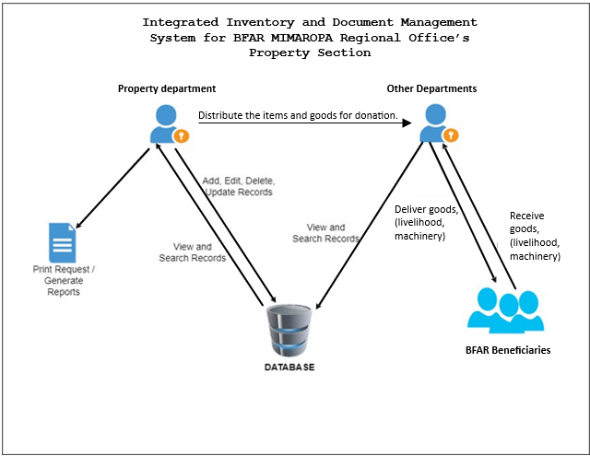 A system architecture shows the representation and structure of the system. In figure 13, it shows the system architecture of the Integrated Inventory and Document Management System for BFAR MIMAROPA Regional Office’s Property Section and the overall process of the system.

**Use case Diagram**

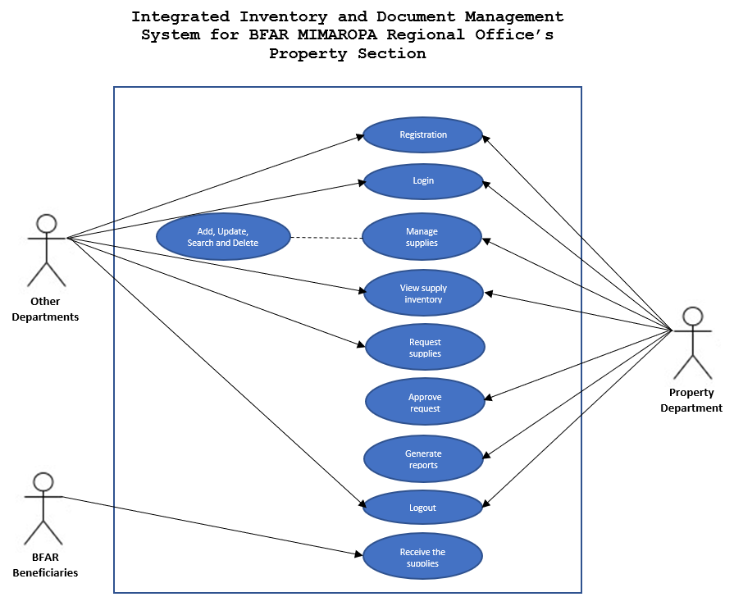The diagram shows the activity of the Property department and other departments in handling the supplies in the inventory. The Property department has the privilege of managing the supplies (Add, Update, Search and Delete). They also have the access to manage reports, approve, requests, generate reports, transactions, and other functions. The Other departments only has the privilege of viewing and searching for the supplies inputted by the Property department, in addition to that, they can also request supplies for donations on BFAR beneficiaries in partner with the Property department.

**Activity Diagram**

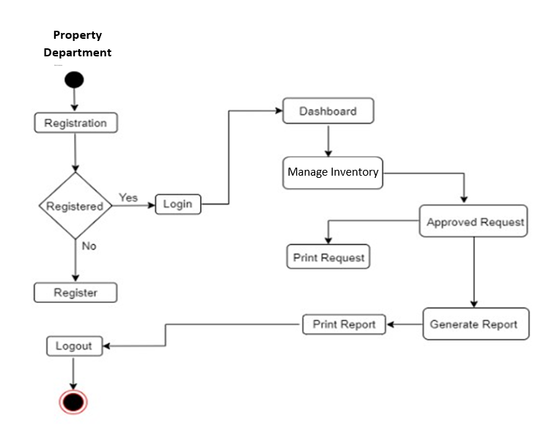 This section of the document illustrates how the project moves forward using a flowchart that focuses on objects. The goal is to depict how the system behaves in action rather than getting into the details of how it's built.

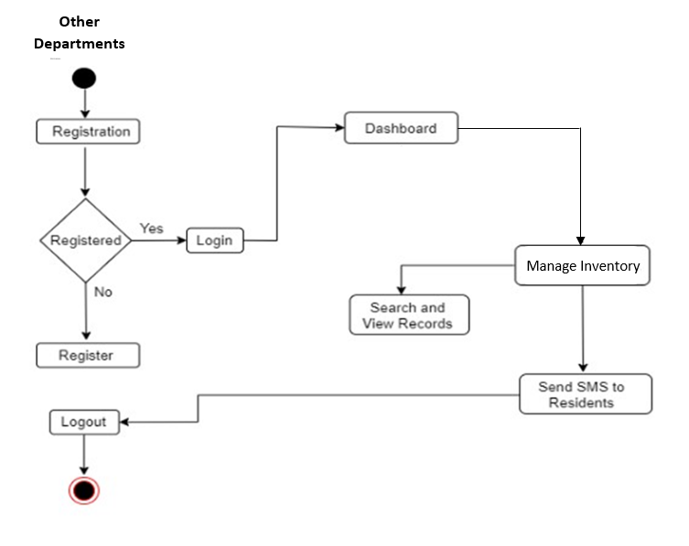

**Data Flow Diagram (DFD)**

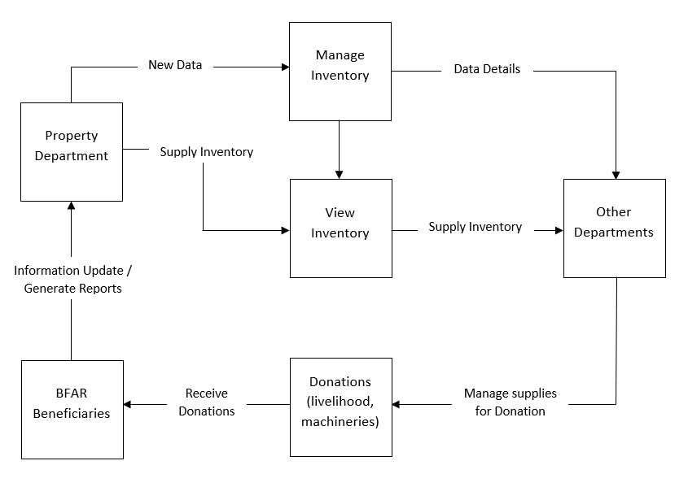A data flow diagram is like a map that illustrates how information moves within the processes of a system. In this context, we will talk about the context diagram and diagram 0.

**Context Diagram**

This presents the basic overview of the whole system or process being analyzed.

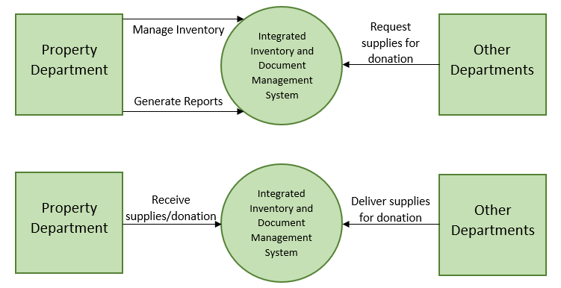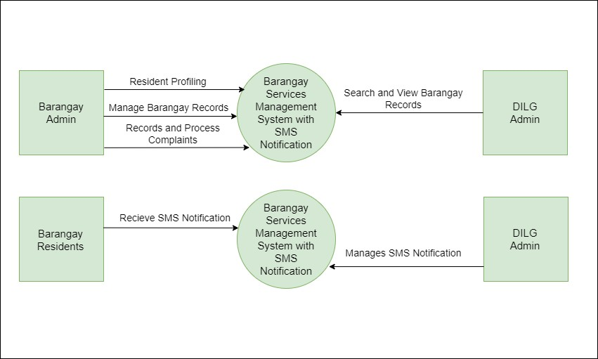

**Database Schema**

The system design played a crucial role in the study's progress. During this stage, we outlined the characteristics of the components in the system. This enables users to see the features of current components and describes the data gathered in the study.

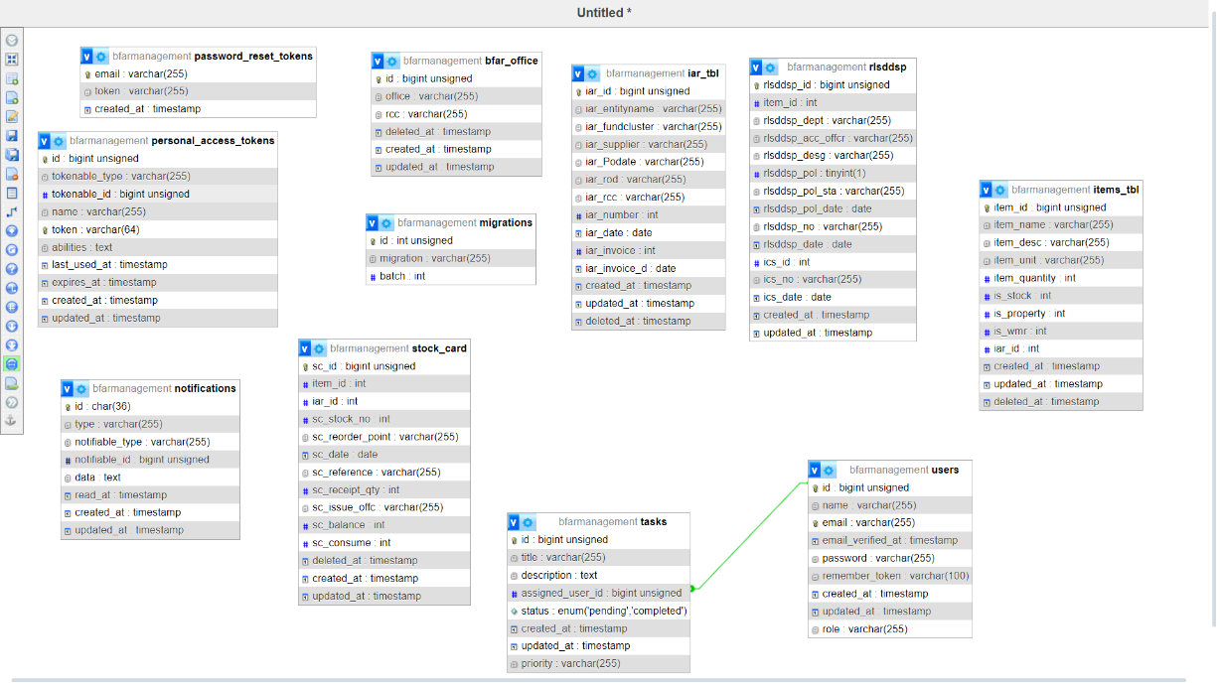

**Testing and Evaluation**

In order to identify the system's strengths and weaknesses during the development stage and enable fixes and production deployment, all of the tests carried out by the researchers are published here. In terms of evaluation, the proponents ensure that the testing phase considers everything that was anticipated during the requirements phase. The performance and supportability of the designs are compared to determine how far they have advanced.

1. Unit Testing - The tests are executed by the developers. This tests every module, feature, and function of the system. It pinpoints the areas in which your system is malfunctioning.
2. Component Testing – this test is done by the Testers after Unit Testing.
3. System Integration Testing - Made comprised of several subsystems, this is a thorough analysis of the system as a whole. Ensuring data integrity and correct operation of all software module dependencies is its aim.
4. Unit Acceptance Testing - This test is conducted with end users and clients, who have the last say on whether to accept or reject it.

**Participants of the Study**

The respondents to the study were composed of the workers of the Property Section in BFAR, employee and IT experts.

**Data Gathering Instrument**

In the study, the researchers gave out surveys to the people participating in the research. The information collected from the participants would help gather the necessary details for the system. The researchers used a rating scale questionnaire with a Likert scale to gather information from the respondents.

|  |  |  |
| --- | --- | --- |
| Scale | Range | Verbal Interpretation |
| 5 | 4.51 - 5.00 | Strongly Agree |
| 4 | 3.51 - 4.50 | Agree |
| 3 | 2.51 – 3.50 | Moderately Agree |
| 2 | 1.51 - 2.50 | Disagree |
| 1 | 1.00 – 1.50 | Strongly Disagree |

**Implementation Plan**

The researchers provide the implementation plan for the customer. The Property Department in the BFAR MIMAROPA Regional’s Office will be in charge of maintaining and overseeing the system. The researchers will give the system and its documentation to the customer so that it may be utilized as the basis for the system.

The terms and conditions of the project's implementation were outlined in a letter of agreement produced by the researchers.

**References**

Abacı, K., & Medeni, I. T. (n.d.). Efficiency of electronic document management systems: A case study 1. Imcra-az.org. Retrieved November 25, 2023

Andriansyah, R., & Elmi, F. (n.d.). Analysis of the effect of electronic document management system, organizational commitment, and work satisfaction on employee performance PT. Graha Fortuna purnama. Ijisrt.com.

Antonova A.S., 2019. Development of a method for planning business processes based on simulation-evolutionary modeling, PhD thesis.

AZ Abdulhamidovna - Confrencea, 2023. THE STRUCTURE OF DOCUMENT MANAGEMENT SYSTEMS THEIR PLACE AND ROLE IN THE MANAGEMENT OF EDUCATIONAL INSTITUTIONS - confrencea.org

Bals, L., Schulze, H., Kelly, S., & Stek, K. (2019). Purchasing and supply management (PSM) competencies: Current and future requirements. Journal of Purchasing and Supply Management, 25(5), 100572. https://doi.org/10.1016/j.pursup.2019.100572

C. Vanessa Muñoz Macas, J. Andrés Espinoza Aguirre, R. Arcentales-Carrión and M. Peña, "Inventory management for retail companies: A literature review and current trends," 2021 Second International Conference on Information Systems and Software Technologies (ICI2ST), Quito, Ecuador, 2021, pp. 71-78, doi: 10.1109/ICI2ST51859.2021.00018.

Cruz,,. J., & Reyes, M. (2019). A Case Study on Inventory Management Practices of Selected Small and Medium Enterprises in the Philippines. International Journal of Supply Chain Management, 619-627.

Davali, M. M., & Poorahmadzadeh, S. (2023). Identifying and ranking the antecedents affecting the implementation of the electronic document management system and its effect on client satis-faction. Human Information Interaction, 10(1), 90–98.

Ferro, N. (2020). Functionality analysis and information retrieval in electronic document management systems. https://thesis.unipd.it/handle/20.500.12608/22993

Israilova S., Mukhanova A., Yesikova T., 2021. Research and assessment of the state of technical objects based on computer modeling. Journal of Theoretical and Applied Information Technology 99.24, 6291–6297.

Jalal, M. J. (2022). Analysis and modeling the electronic document management system of ministries of Iraq. Al-Salam Journal for Engineering Science and Technology, 1–10. https://doi.org/10.55145/ajest.2022.01.01.001

Jang, S.-H., & Jeong, J. (2019). Design and Implementation of OpenCV-based Inventory Management System to build Small and Medium Enterprise Smart Factory. The Journal of The Institute of Internet, Broadcasting and Communication, 19(1), 161–170. https://doi.org/10.7236/JIIBC.2019.19.1.161

Jauhari, W. A., Pujawan, I. N., & Suef, M. (2023). Sustainable inventory management with hybrid production system and investment to reduce defects. Annals of Operations Research, 324(1–2), 543–572.

Javaregowda, Madhuri & B, praveen & Kumar, Pradyumna & J, Prateek & G, Pragathi. (2020). Inventory management using Machine Learning. International Journal of Engineering and Technical Research. 9.

M. Shanmugaraja, P. Manojkumar, K. P. N. Govarthan, and R. Nandhakumar, “Analyzing Inventory Management System in Textile Spinning Mill for Improving Productivity”, IJRESM, vol. 3, no. 8, pp. 388–394.

Makwae, E. N. (2021). Legal frameworks for personnel records management in support of accountability in devolved governments: a case of Garissa County Government. Records Management Journal, 31(2), 109–133. https://doi.org/10.1108/rmj-05-2019-0024

Mariom Akter, M. (2019). STASH - An Inventory Management System. http://dspace.uiu.ac.bd/handle/52243/1509

Mukamba, J., Twinomugisha, B., Barigye, S., & Nimusiima, D. (2022). A document management system for case files at Mmaks advocates. Makerere University.

Munyaka Baraka, Jean-Claude & Yadavalli, Sarma. (2022). Inventory management concepts and implementations: a systematic review. South African Journal of Industrial Engineering. Vol 33, No 2. 15-36. 10.7166/33-2-2527.

Nakibondwe, R., Okuga, S., Awor, H., Kyampeire, B., Kutusiime, A., & Nabuyobo, P. (2021). A document management system for Kampala Capital City Authority KCCA. Makerere University.

Özgür Polat, L. (2022). Digital transformation process in selection and implementation of an electronic document management system. In Advances in Business Strategy and Competitive Advantage (pp. 62–84). IGI Global.

Paul, & Estrera, Paul Joseph & Teresa, Maria & Fajardo, Maria Teresa & Sermona, Nivea Louwah & Sermona, D. (2022). A WEB-BASED DOCUMENT MANAGEMENT SYSTEM FOR EXTENSION OFFICE. 453-458.

Rachih H., Mhada F.Z., Chiheb R., 2022. Simulation optimization of an inventory control model for a reverse logistics system. Decision Science Letters l.11.1, 43–54.

Sadabadi, A. A., Sheykh Shoaei, H., & Rahimi Rad, Z. (2022). Investigating factors affecting the acceptance of electronic document management system in Iran Gas Company. Sciences and Techniques of Information Management, 8(4), 213–250. https://doi.org/10.22091/stim.2021.7222.1627

Sarang, S., Rana, D., Patel, S., Savaliya, D., Rao, U. P., & Chaurasia, A. (2022). Document management system empowered by effective amalgam of blockchain and IPFS. Procedia Computer Science, 215, 340–349. https://doi.org/10.1016/j.procs.2022.12.036

Stolyarov, V.; Pásztorová, J.; Zos-Kior, M.; Hnatenko, I.; Petchenko, M. 2022. OPTIMIZATION OF MATERIAL AND TECHNICAL SUPPLY MANAGEMENT OF INDUSTRIAL ENTERPRISES Scientific Bulletin of National Mining University.Issue 3, p163-167. 5p

Tahi̇luddi̇n, A., & Terzi̇, E. (2021). An overview of fisheries and aquaculture in the Philippines. Journal of Anatolian Environmental and Animal Sciences, 6(4), 475–486.

Thasakdinan, N., & Rungsrisawat, S. (2019). Satisfaction of document management. INTERNATIONAL ACADEMIC MULTIDISCIPLINARY RESEARCH CONFERENCE IN BERLIN 2019, 161–165. http://icbtsproceeding.ssru.ac.th/index.php/ICBTSBERLIN2019/article/view/663

Weißhuhn S., Hoberg K., 2021. Designing smart replenishment systems: Internet-of-Things technology for vendor-managed inventory at end consumers. European Journal of Operational Research 295.3, 949–964.

Yuvaraj, K., Oorappan, G. M., Megavarthini, K. K., Pravin, M. C., Adharsh, R., & Ashwath Kumaran, M. (2020). Design and development of an application for database maintenance in inventory management system using Tkinter and SQLite platform. IOP Conference Series. Materials Science and Engineering, 995(1), 012012.